SOFTWARE TESTING REPORT
Module Name: Book Management - Functional Test Cases
Test Case ID: TC001
Webpage / Program: Book Management System
Scenario ID: TC001
Scenario: Add and display books
Test Steps:
- 1. Run the Book Management program.
- 2. Select Add Book, enter a book name, and select Display Books.
Test Input: Book Name: Python Basics
Expected Result: The book should be added successfully and displayed in the book list.
Actual Result: Book added and displayed successfully.
Status: Pass
Screenshot:
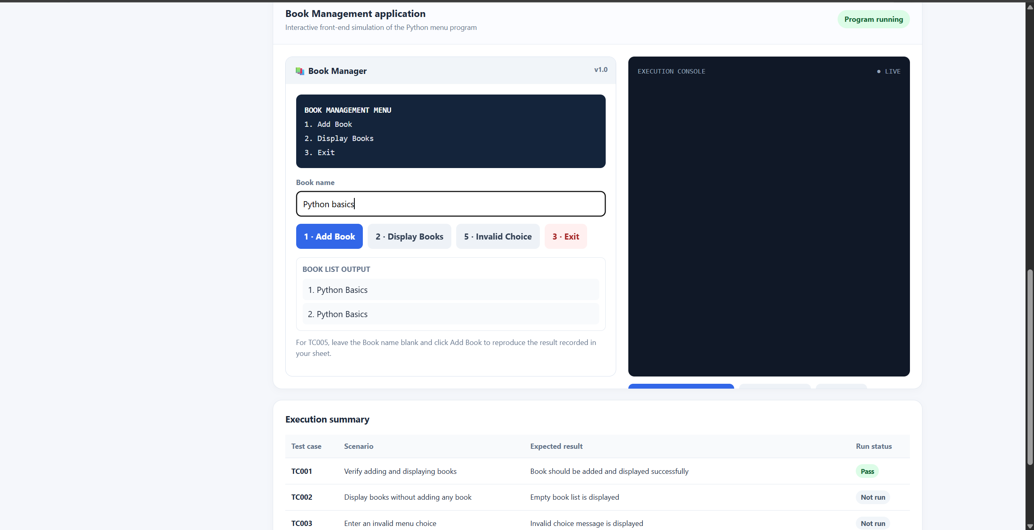
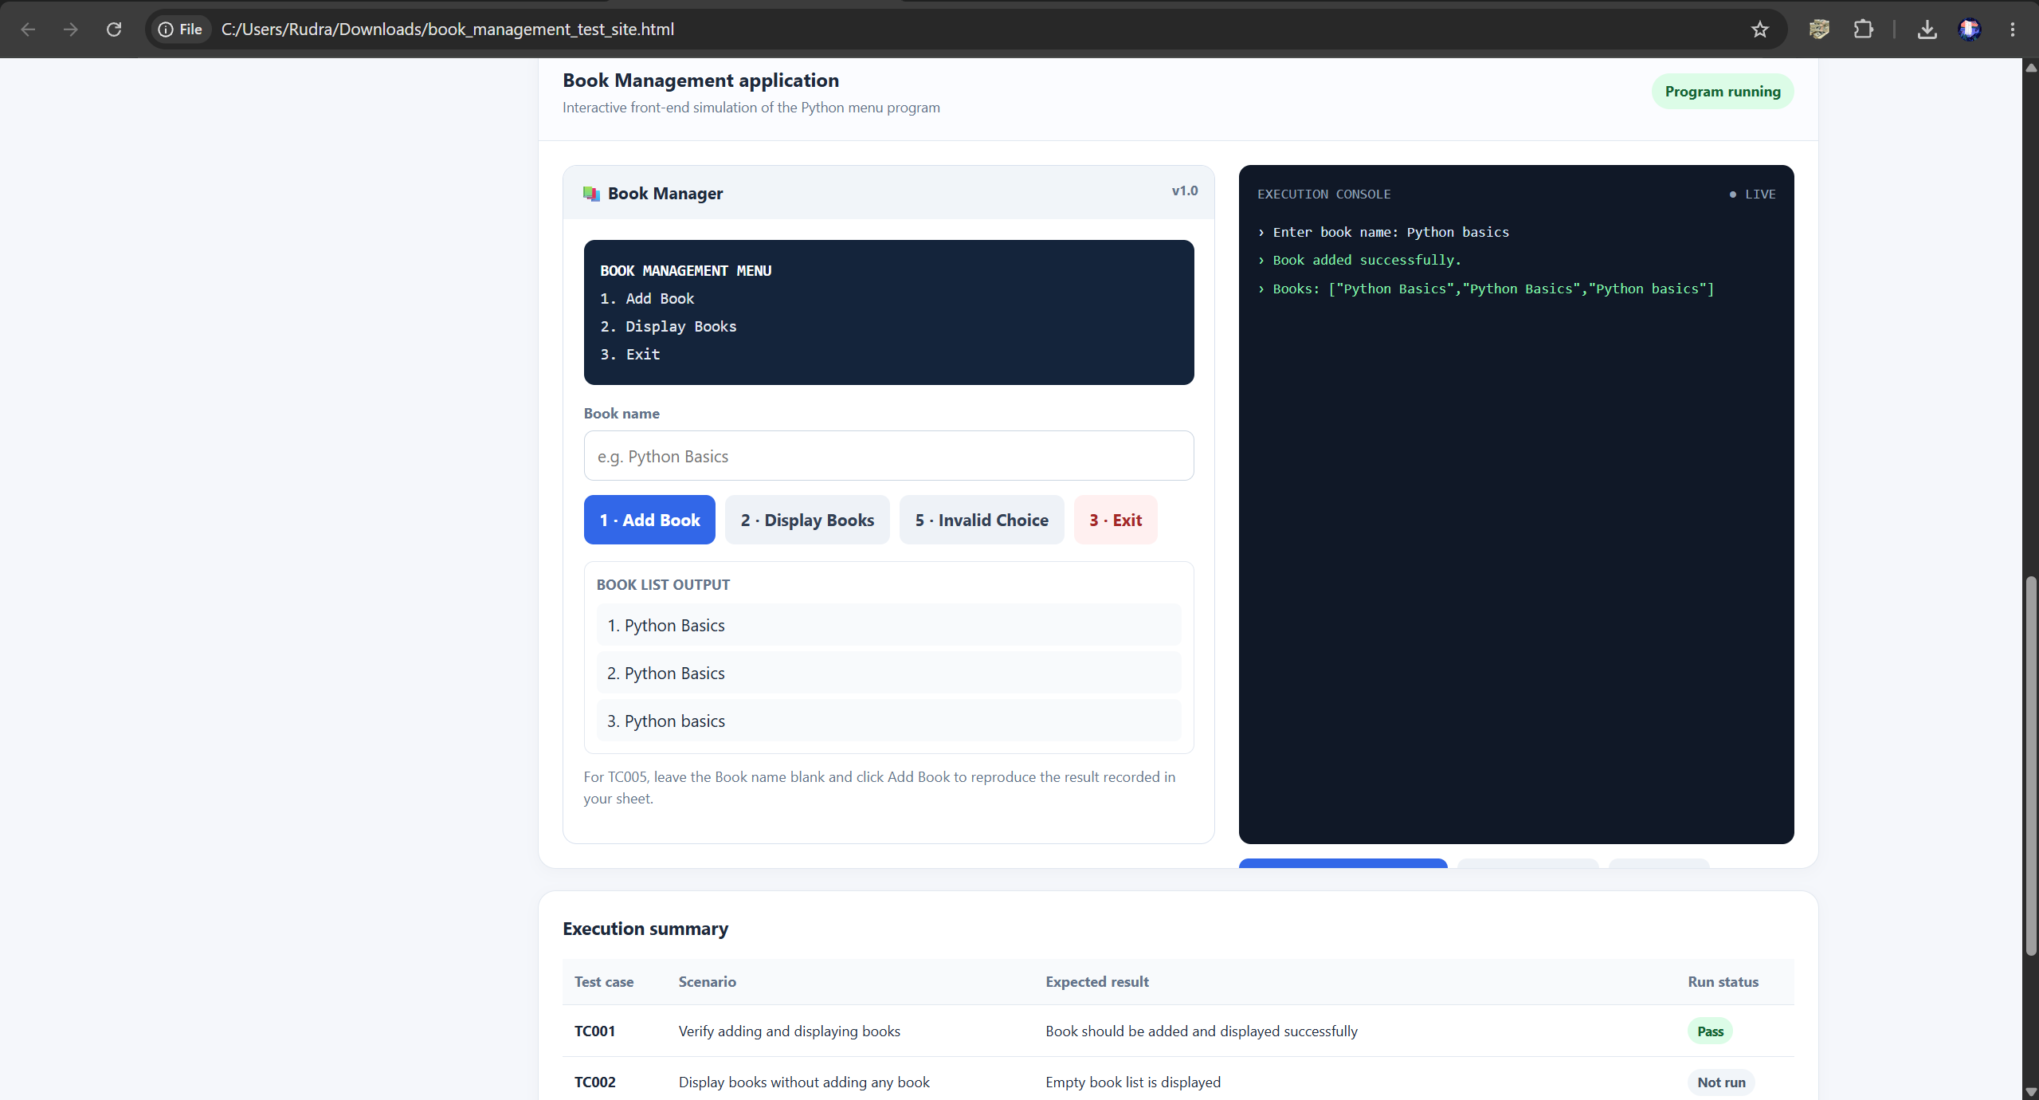
Scenario ID: TC002
Scenario: Display books without adding any book
Test Steps:
- 1. Run the Book Management program.
- 2. Select Display Books without adding a book.
- 3. Select Exit.
Test Input: Choice: 2 (Display Books); no books added
Expected Result: The empty book list should be displayed.
Actual Result: Books: []
Status: Pass
Screenshot:
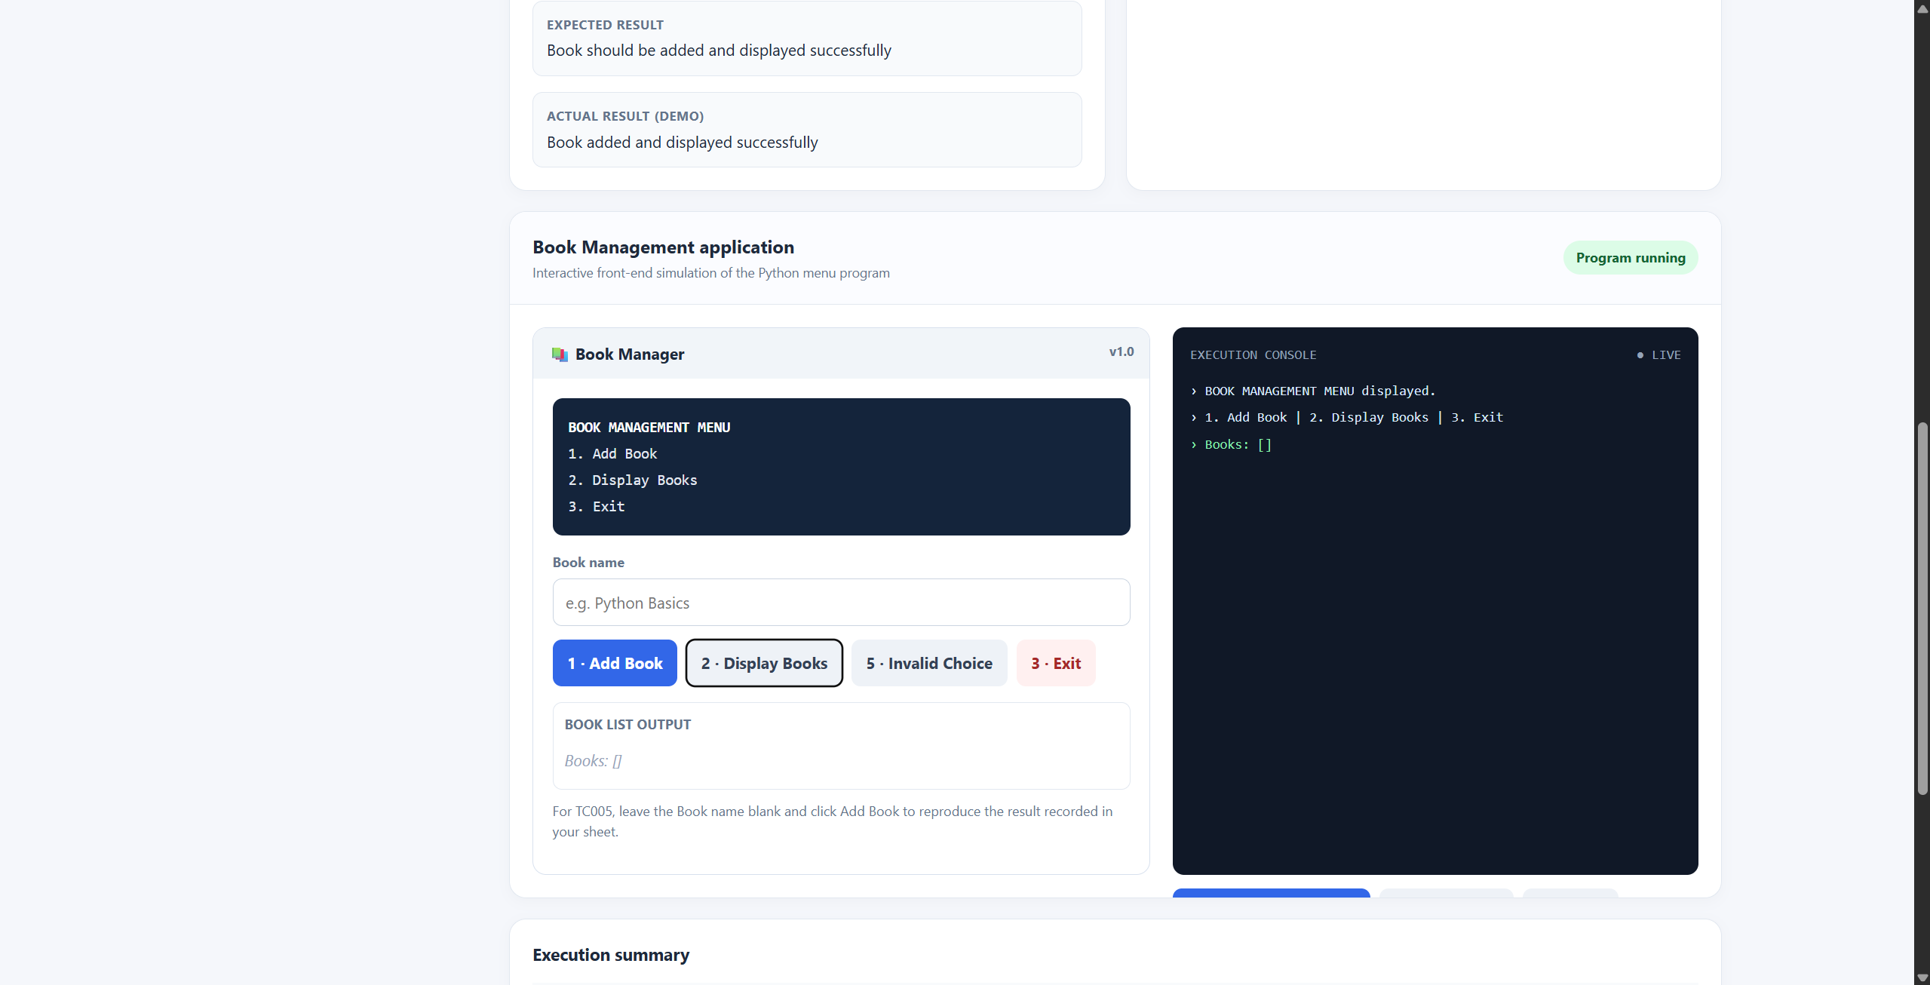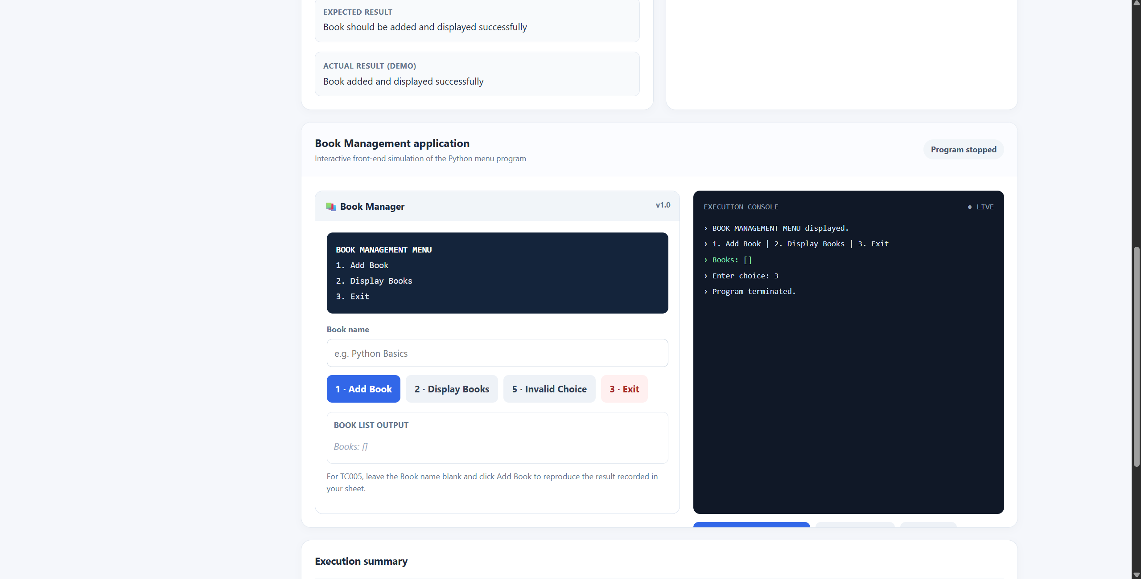
Scenario ID: TC003
Scenario: Enter an invalid menu choice
Test Steps:
- 1. Run the Book Management program.
- 2. Enter an invalid menu choice (5).
- 3. Check the menu response and select Exit.

Test Input: Choice: 5
Expected Result: An invalid choice message should be displayed and the menu should appear again.
Actual Result: Invalid choice message is displayed.
Status: Pass
Screenshot: 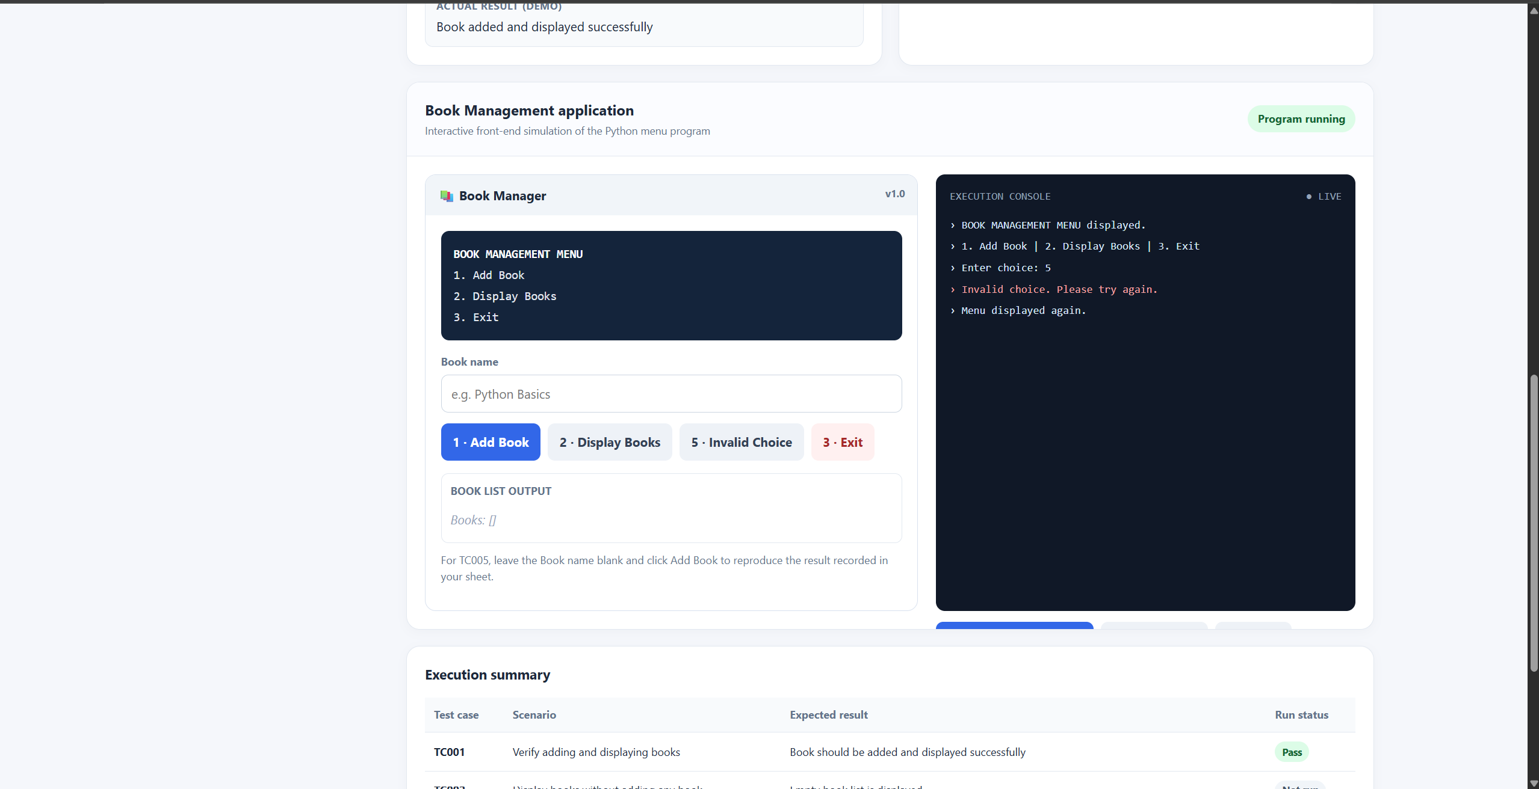
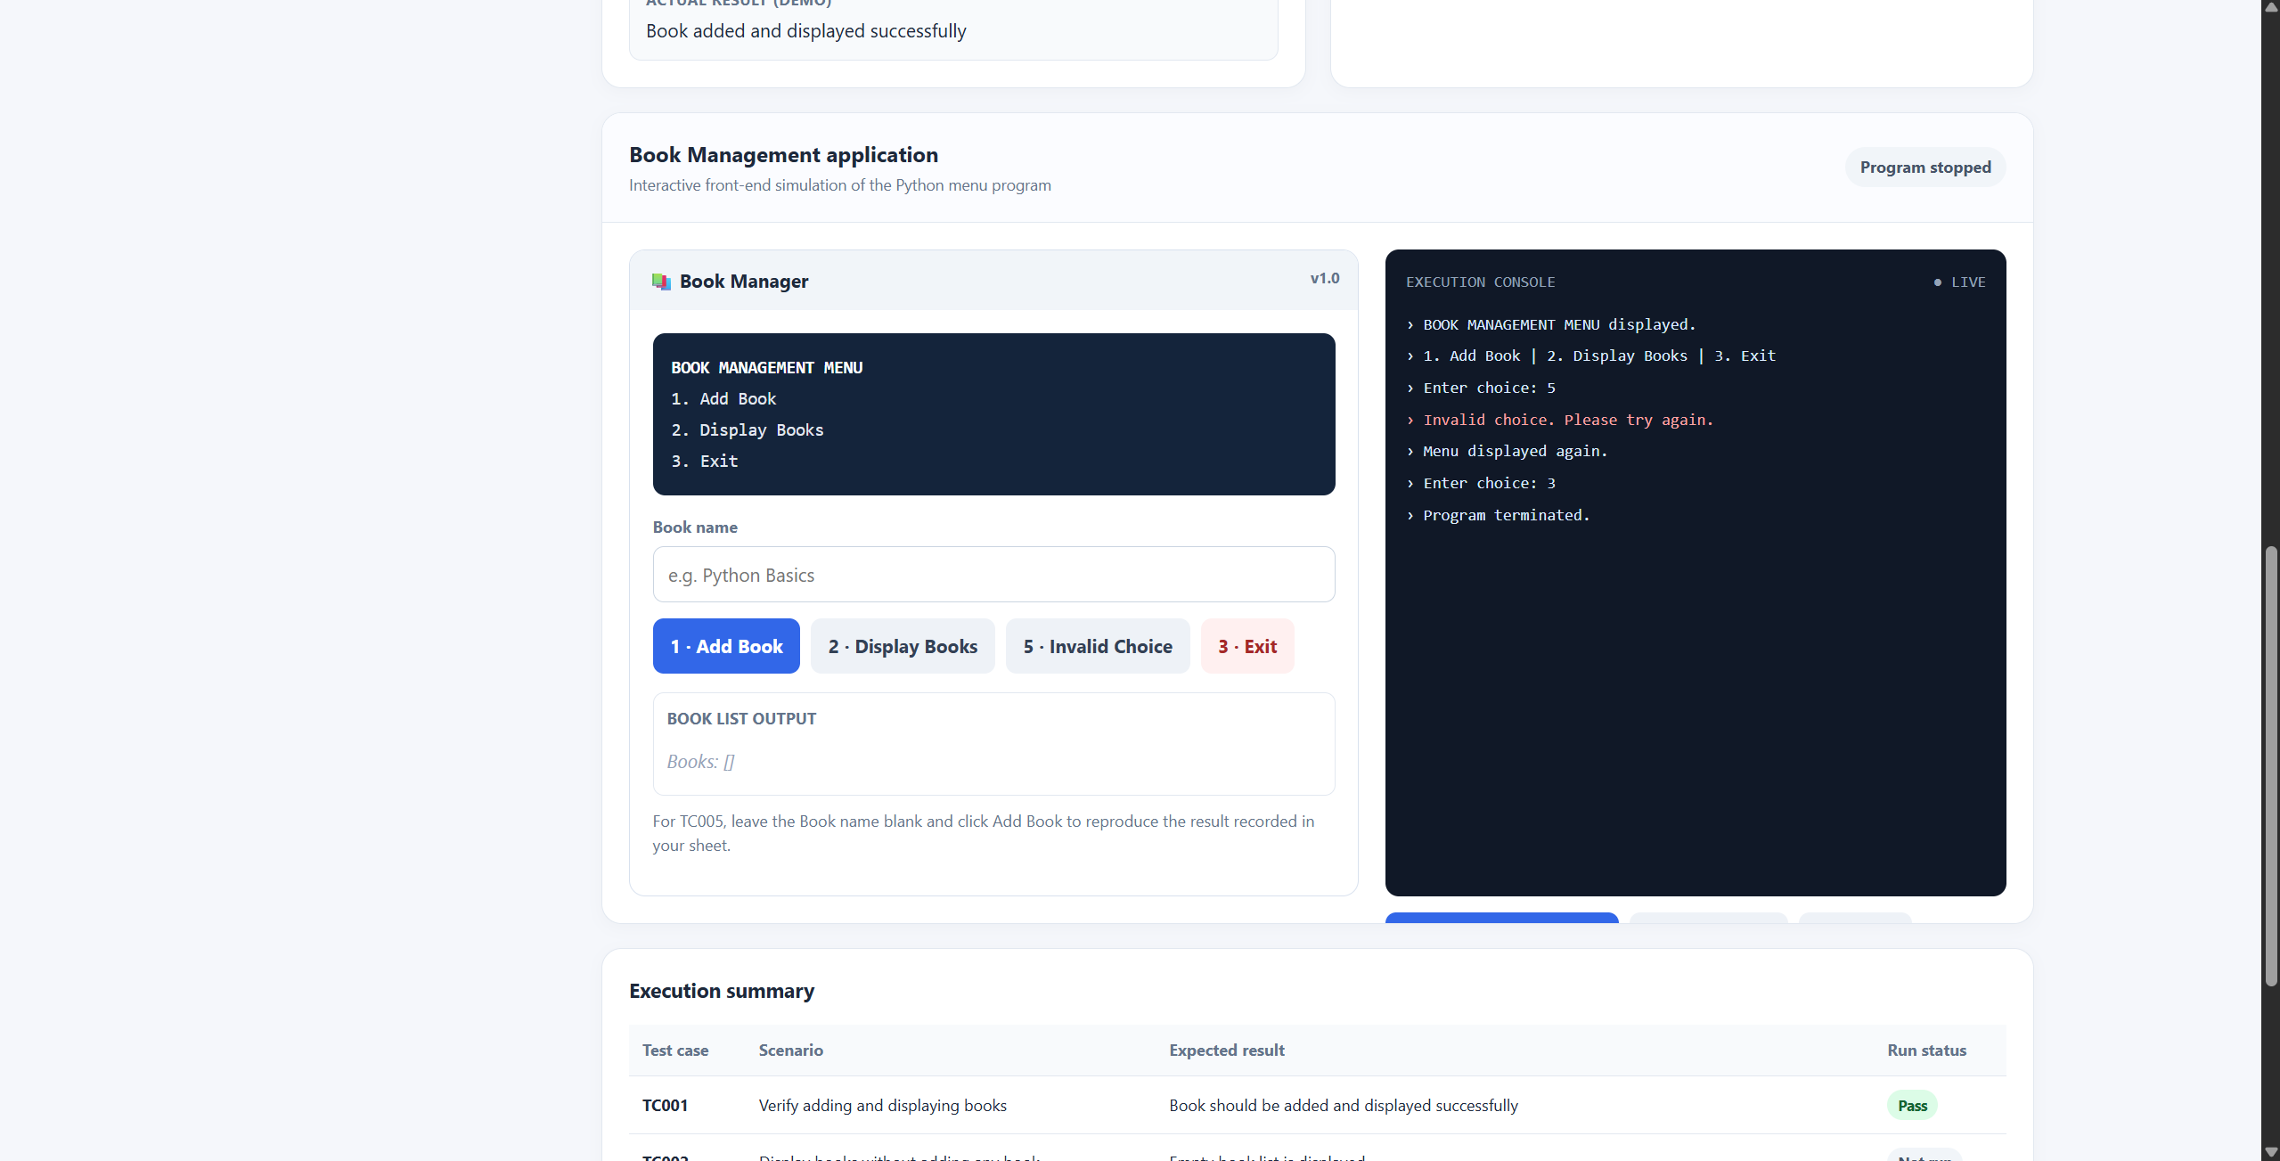
Scenario ID: TC004
Scenario: Add two books and display the list
Test Steps:
- 1. Run the Book Management program.
- 2. Select Add Book and enter Python Basics.
- 3. Select Add Book again and enter Java Introduction.
- 4. Select Display Books, then Exit.
Test Input: Book Names: Python Basics, Java Introduction
Expected Result: Both books should be added and displayed in the list.
Actual Result: Both books are added and displayed.
Status: Pass
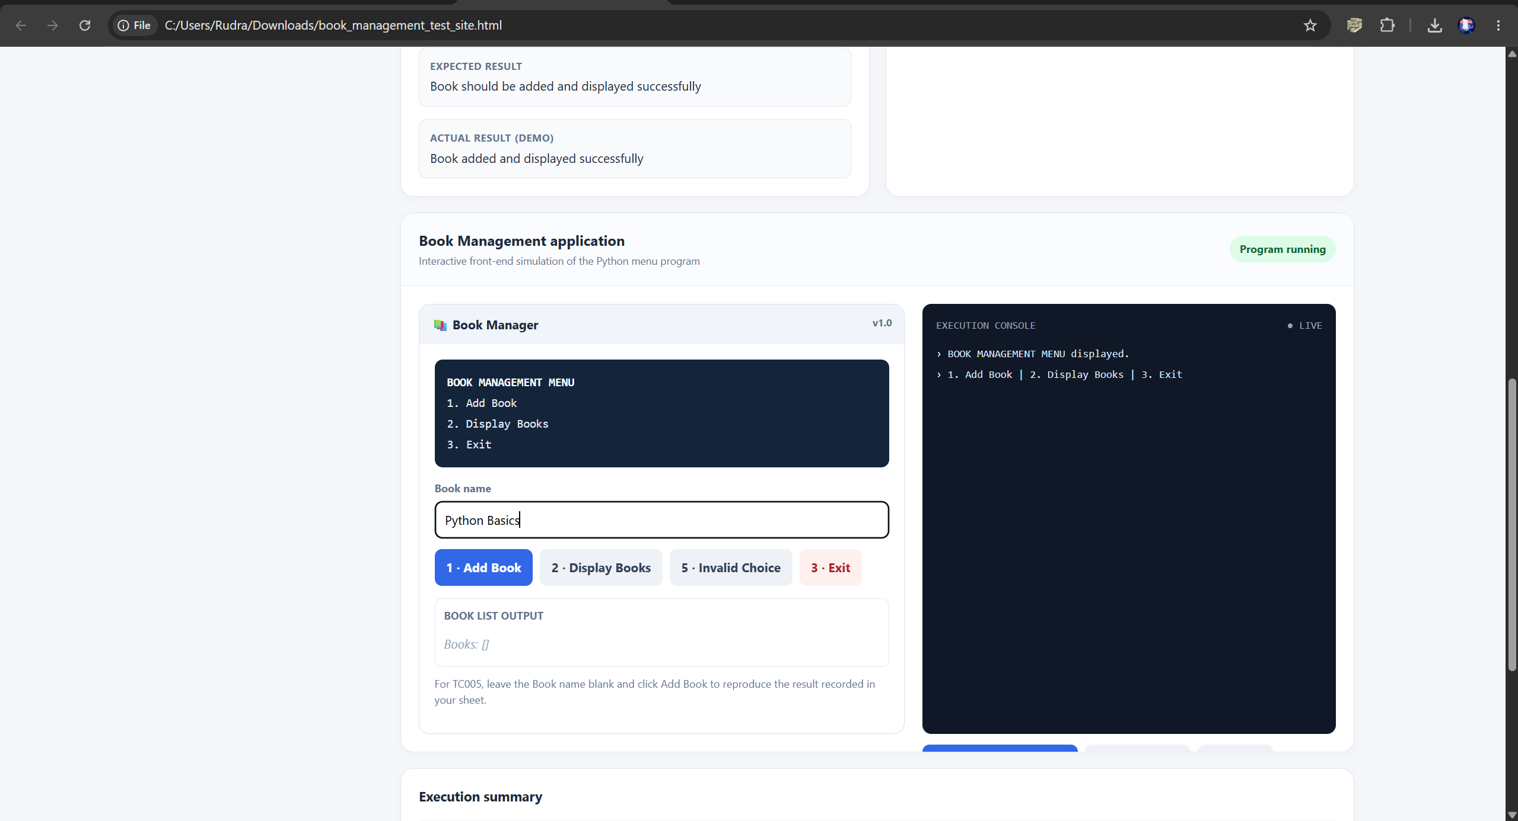
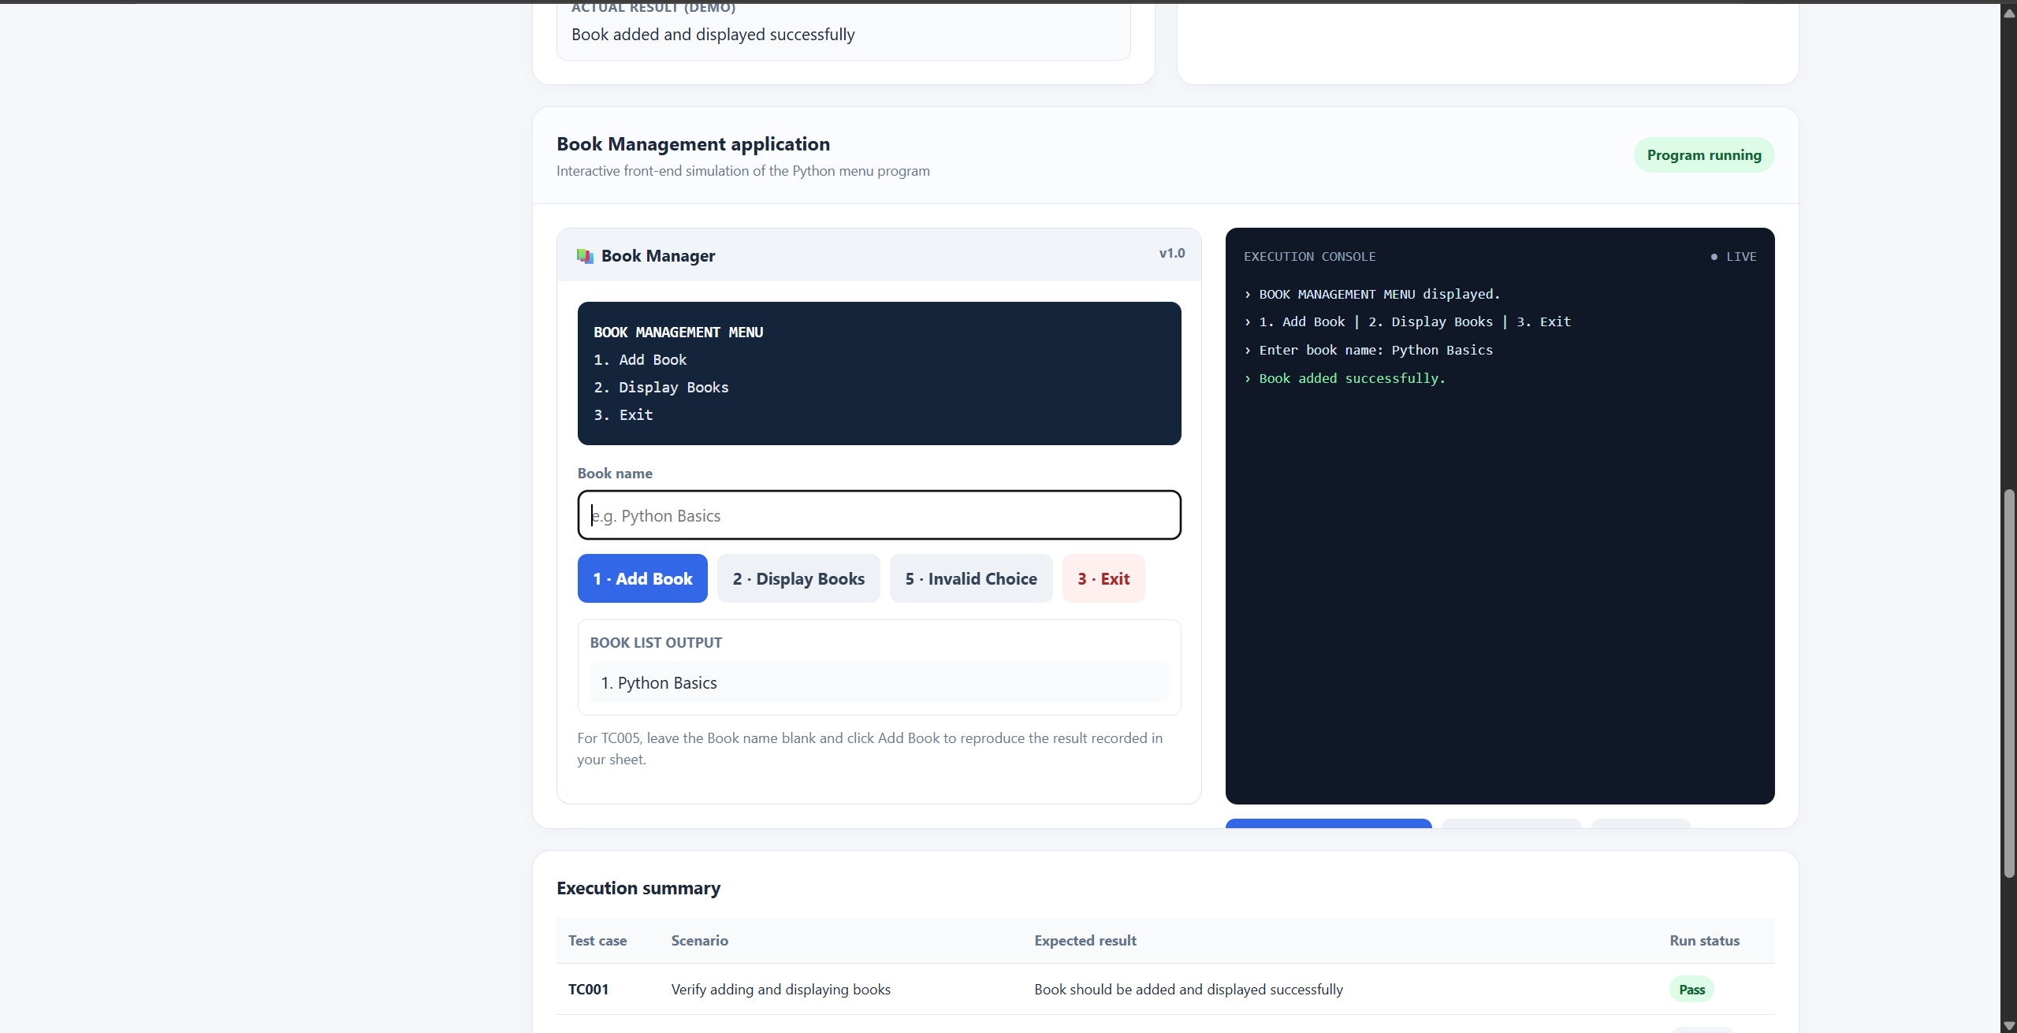
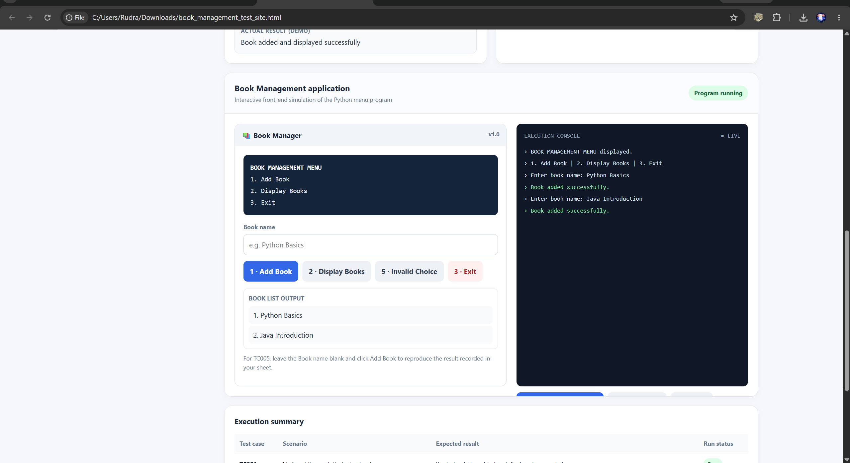
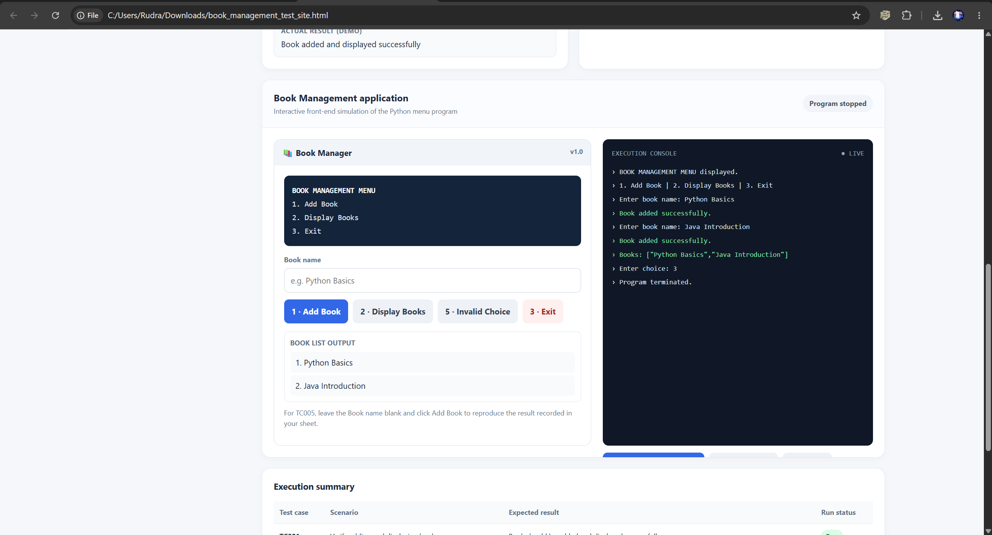
Scenario ID: TC005
Scenario: Add a book without entering a book name
Test Steps:
- 1. Run the Book Management program.
- 2. Select Add Book.
- 3. Press Enter without entering a book name.
- 4. Select Display Books and then Exit.
Test Input: Book Name: Blank
Expected Result: The program accepts the empty book name and displays “Book added successfully,” matching the provided test sheet.
Actual Result: Book added successfully.
Status: Pass
Screenshot:
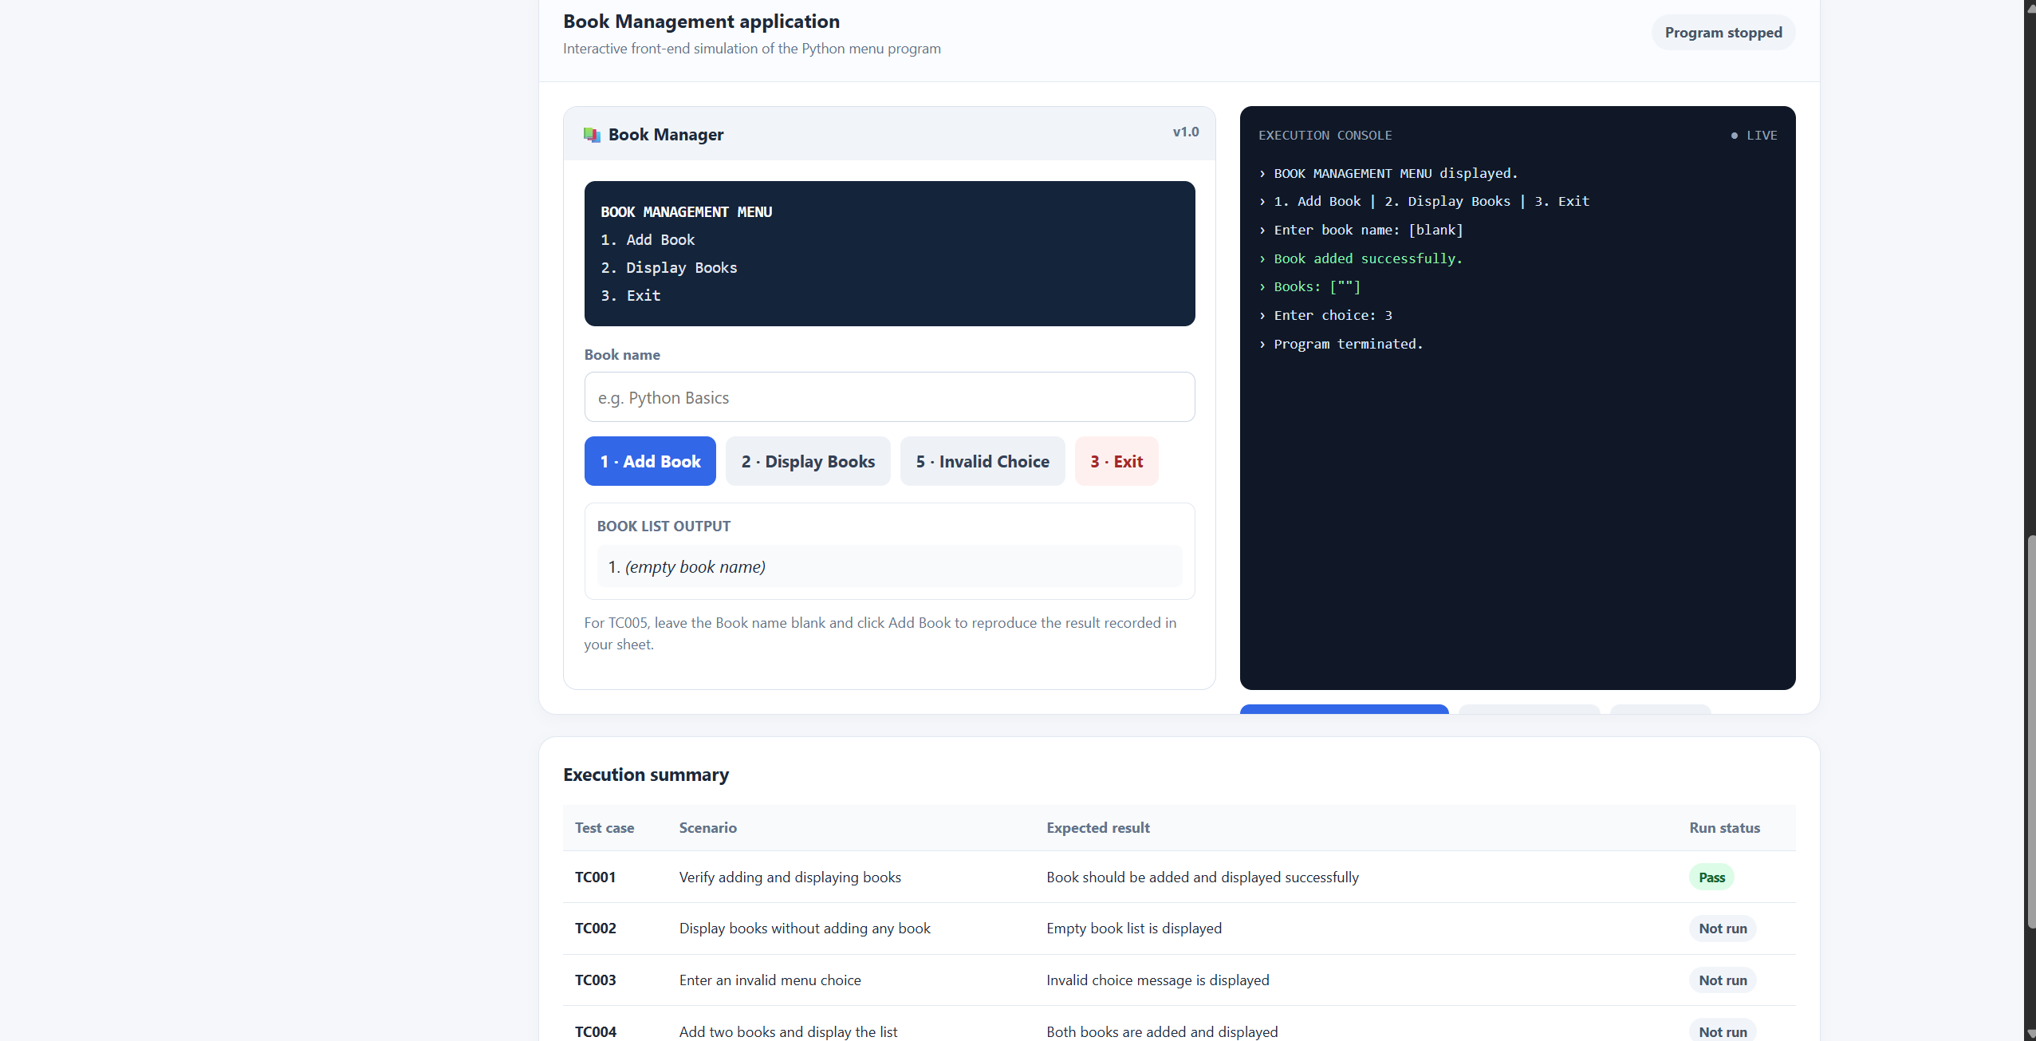
Summary of Test Results
Total Test Scenarios | 5
Passed | 5
Failed | 0
Pass Percentage | 100

Conclusion and Recommendations
The report covers five Book Management test scenarios: adding and displaying a book, displaying an empty list, handling an invalid menu choice, adding multiple books, and accepting an empty book name. Insert the corresponding screenshots and update the Actual Result and Status fields if execution differs.
Recommendation: Verify that books are stored and displayed correctly, empty lists are handled properly, invalid menu choices show an appropriate message, and empty book names behave as documented in the test case.

